Assignment 3 – Convolutional Neural Network
CSCI 436
Ella Bryant
931097236
The implementation of the Convolutional Neural Network on the MNIST dataset was split into four source code files labeled as: “model.py” (the file containing the framework of the model), “training.py” (training algorithm), “testing.py” (testing algorithm), and “main.py” (runs the other files on the MNIST dataset).
Model Framework Implementation
The Python Pytorch was library was imported to use as the framework for building the custom Convolutional Neural Network.
To create the Convolutional Neural Nework, the Pytorch library’s class nn.Module was used as an inheritance class to provide the framework for creating a custom model. Therefore, the class and constructer function were initialized as shown below.
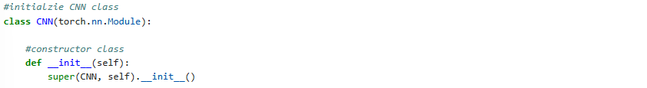
Bonus: Inclusion of both Batch Normalization and Max Pooling
The framework of the model was selected to maximize the trainability under the outlined requirements. Thus, both hatch normalization and max pooling were included in the implementation. The overall framework is as follows:
Input Convolution Layer 1 Batch Normalization Convolution Layer 2 Batch Normalization ReLU function Dropout function Convolution Layer 3 Max Pooling Residual Stages Flattening Function Fully Connected Layer 1 ReLU function Dropout Function Fully Connected Layer 2 Output
The description of implementation of the above framework is described below.
The Convolution Layers were initialized next. Since the framework is being created specifically for the MNIST dataset, the layer’s variables were built using the assumptions of the inputs being a 28x28 pixel image in grayscale. Therefore, the first convolution layer had an input channel of 1 for since grayscale does not add additional dimensions to the input, and it had an output channel of 8 to get into standard format of a networks hyperparameters. The standard kernel and stride size were selected along with 2 layers of padding to preserve spatial dimensions.
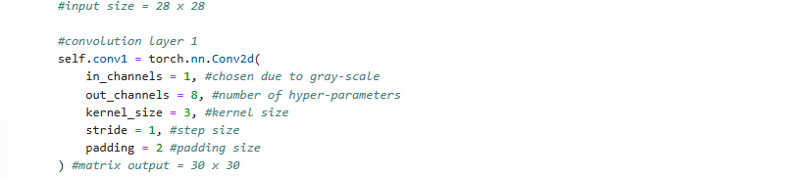
Thus, the output size can be computed using the following formula.
$$Out_{size}=\frac{W_{img}-K+2P}{S}+1=\frac{28-3+2\left(2\right)}{1}+1=30$$
The convolution channel outputs were then used to run the resulting data through the first iteration of batch normalization.
Thus, the next convolution layer was computed implemented with the intention of condensing the data into a 16 x 16 matrix. A kernel size of 2, step size of 2 and padding size of 1 was selected for this result as shown below.
$$Out_{size}=\frac{W_{img}-K+2P}{S}+1=\frac{30-2+2\left(1\right)}{2}+1=16$$
The input and output channels were determined by the standard of doubling the input channels for each layer in the convolution.
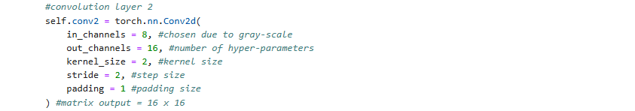
This convolution was then run through batch normalization and the ReLU function to balance out the data. The input of the batch normalization was once again the channel outputs of the last convolution layer which was 16.
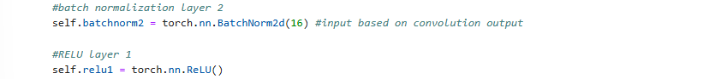
This convolution was completed with an iteration of a dropout function to minimize potential for overfitting. The probability was selected to be 0.25 to balance between overfitting and underfitting.
Thus, the third and final convolution layer was initialized with the standard convolution values to keep the output size a 16 x 16 matrix. A kernel size of 3, step size of 1 and a padding layer of 1 were selected for this purpose as shown below.
$$Out_{size}=\frac{W_{img}-K+2P}{S}+1=\frac{16-3+2\left(1\right)}{1}+1=16$$
The input and output channels were determined by the standard of doubling the input channels for each layer in the convolution.
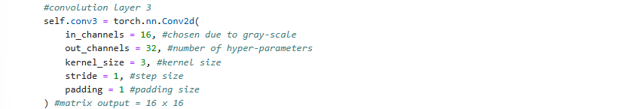
With the convolution layers complete, the next task is pooling that output to a smaller matrix. The MaxPool2d function from the Pytorch library was selected using standard kernel and stride sizes of 2 respectively. Thus, the output was a 8 x 8 size matrix.
Bonus: Residual Stages
The residual stages were added to further optimize training later. This is reminiscent of the ResNet algorithm; however, in this implementation there is only one skip connection.
The implementation of this section of the model was performed in a separate class which was once again implemented by inheriting from the nn.Module class in Pytorch. As such the initialization of the class and constructor function can be seen below.
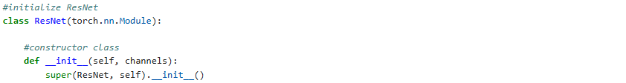
The class has a channel input for the current number of hyper parameters for a given input. In the context of our data and current model implementation. The number of hyperparameters is 32 which is shown in the class initialization below back in our CNN framework.
The residual framework starts with its own convolution layer. The in and out channels are the same size because this is necessary for the skip connection later. Once again with our data, the input matrix should be an 8 x 8 matrix, and for the skip connection to function, the matrix must stay the same size. Therefore, a kernel size of 3, stride of 1 and padding of 1 were selected as shown below.
$$Out_{size}=\frac{W_{img}-K+2P}{S}+1=\frac{8-3+2\left(1\right)}{1}+1=8$$
Thus, the convolution layer was implemented as shown below.
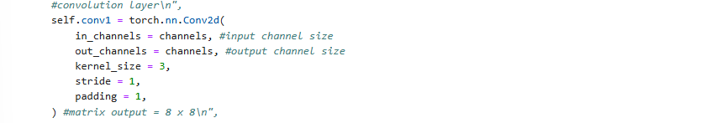
The output of that convolution layer was then run through batch normalization once again using the channel size indicated based on the output of the convolution layer. Then the ReLU function was run to delineate the data.
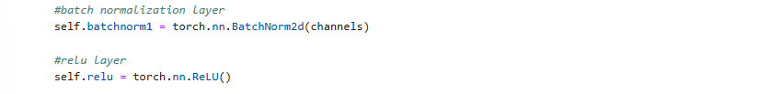
The residual framework continues with a second convolution layer. Due to the reasoning explained in the first convolution layer, the parameters of this convolution layer remained the same.
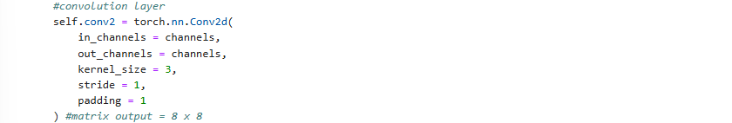
The output of that convolution layer was then run through batch normalization once again using that output of the convolution.
Next, the forward function was implemented in the residual stage class. This class is what gets run when inputs are passed to the model. The forward function connects the two convolution layers with their respective functions as shown below.
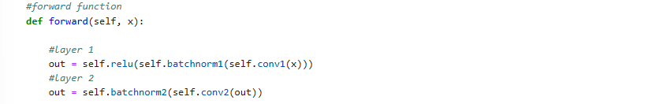
Finally, the skip connection is performed connecting the original input to the output determined by the convolution layers.
With the residual stage completed, the data is then flattened from an 8 x 8 matrix with 32 hyper parameters to a vector, size 2048, to prepare for the fully connected layers.
Thus, the data is ready for the first fully connected layer using the linear function in the Pytorch library. The 2048 size input vector is condensed to a hidden stage of size 128.
The output of the first fully connected layer is then run through the ReLU function to delineate the data. And then it is run through the dropout function with a probability of 0.25 to balance between overfitting and underfitting.
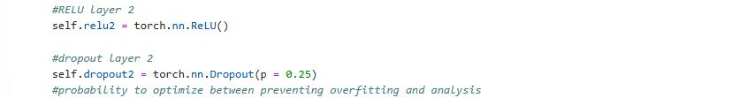
Finally, the second fully connected layer is initialized using the linear function in the Pytorch library. The input size being 128 as determined by the above hidden stage is condensed to an output of size 10 representative of digits 0-9.
Next, the forward function was implemented in the Convolutional Neural Network class. This class is what gets run when inputs are passed to the model. The forward function first connects the three convolution layers with their respective functions as described above.
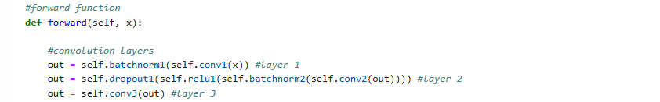
Next sequentially, the convolution layer output is run through the max pool function as described above.
Then, the output of the max pool function is run through the residual stage. This runs the input through the residual stage class’s forward function.
Finally, the output of the residual stage is flattened in preparation for the fully connected layers. These layers are then iterated through with their respective functions as described above.
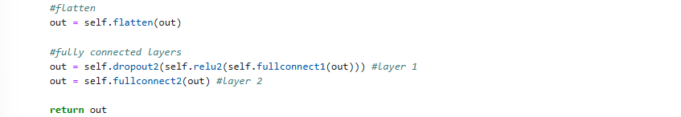
Training Algorithm Implementation
The necessary libraries for the training algorithm were imported first.
- Pytorch was used for interacting with the model and the neural networks API.
- Wandb was used for graphing and keeping track of the model’s training progress.
- CSV was used to save the training data to a file for viewing later.
The training algorithm was implemented in a function with the following constructor and parameters.
The model parameter is for the CNN class instance. The dataloader parameter is for the dataloader class in the Pytorch library containing the training dataset. The epochs parameter is indicating the number of epochs to use for training. The device is the location where computation should occur on the machine.
Next, the optimizer was initialized. The Adam optimizer form the Pytorch model was chosen using the parameters from the uploaded model and a learning rate of 0.0001 since there are 600 epochs used in our implementation.
The loss function is then initialized as the cross-entropy function since the task is that of multiclass classification.
Then, the model is set to train model so that the dropout and batch normalization functions behave as necessary when training.
Next, the data container for training is initialized with the headers: “Epoch”, “Training Accuracy” and “Training Loss”.
Now that all the preliminary initializations are complete, the iteration through the epochs can begin.
For each iteration, of an epoch the placeholders for loss function and accuracy computation are initialized before beginning iteration through the training dataset.
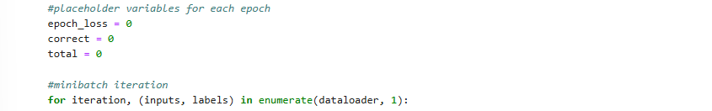
For each iteration of the training data, the inputs and labels are first moved to the respective device for more efficient computation before zeroing out the optimization function.
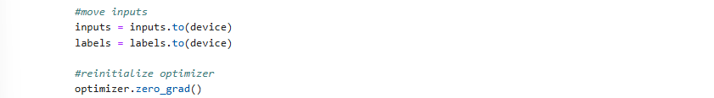
The inputs are run through the model’s forward function as described above generating the outputs. These outputs are used with data labels to compute the cross entropy loss function.
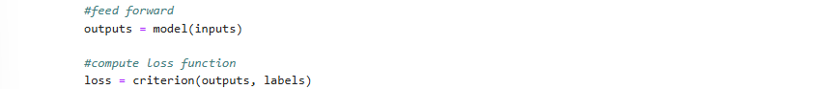
The calculated loss function is then minimized using back propagation. This is then used along with the optimizer to update the weights in the model with gradient descent.
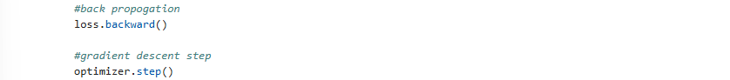
The epoch loss container, correct values and total placeholders are then updated for the current iteration of the training data.
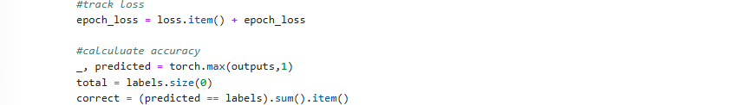
Once the current iteration of the training data is completed, the overall epoch accuracy and loss functions are computed.
This epochs data is then added to the data container to upload to training data file later.
Wandb Implementation
The wandb library is used to graph the progress of the training algorithm during the process. The instance is first initialized before beginning the epoch loop, and it is configured to contain the learning rate being used.
At the end of each iteration of the epoch loop, the training data – epoch, average loss and accuracy – are loaded to the wandb module. This keeps track of the model’s training progress on a remote server.
The data saved within the data container is then loaded to the “model_training.csv” file using the CSV library as described below.
Testing Algorithm Implementation
The necessary files for the testing algorithm were imported first.
- Pytorch was used for interacting with the model.
- CSV was used to save the training output to a csv file.
The testing algorithm was implemented using the following function constructor and parameters.
The model parameter is for the CNN class instance. The dataloader parameter is for the dataloader class in the Pytorch library containing the testing dataset. The device parameter is the location where computation should occur on the machine.
First, the model is set to evaluation mode so the Dropout Function and Batch Normalization Functions will act in accordance with testing criteria.
Next, the container for the testing data is initialized with the following headers: “Label” and “Prediction”, followed by the initialization of the placeholder values for accuracy computation.
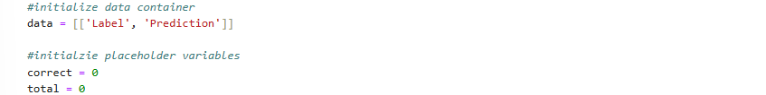
The Pytorch module is set so that it will not compute gradients during computation of the testing data, so the testing dataset can be properly iterated through.
Then, the inputs and labels are moved to the machine device for more efficient computation.
The model is then run on each of the inputs, and the Pytorch max function is used to calculate the predicted values.
Each of the output values is then iterated through and the labels and predicted values are added to the data container.
The total and correct values are then computed for each iteration of the training data before calculating the overall accuracy and adding that to the end of the data container.
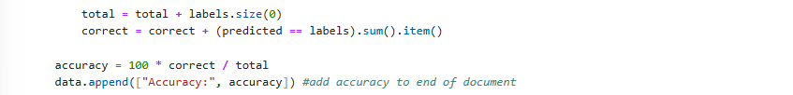
Finally, the computed data in the data container is exported to “model_testing.csv” using the CSV library.
Main File Implementation
The necessary libraries and files were then imported for the main file’s implementation.
- Pytorch for interacting with the model and use of its API’s.
- Torchvision for importing the MNIST dataset.
- Model for the CNN framework as described above.
- Training for the training algorithm as described above.
- Testing for the testing algorithm as described above.
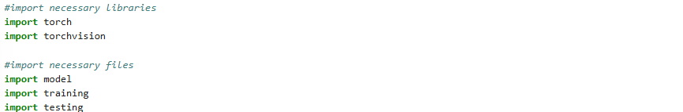
The MNIST datasets were then loaded using the Torchvision library. The training dataset was initialized in train mode and converted to a tensor, while the testing dataset was not initialized in train mode and converted to a tensor.
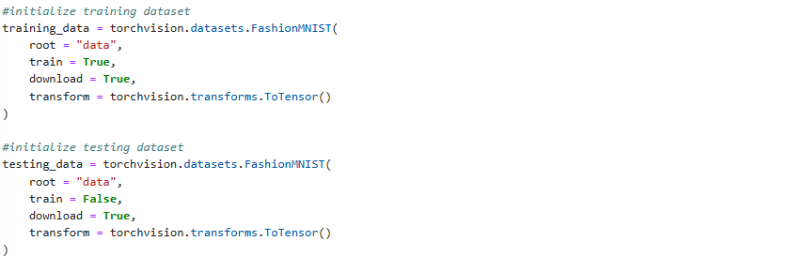
The datasets were then initialized into dataloader classes from the Pytorch library for easier computation using batch sizes of 100. The training data was put on shuffle mode while the testing data was not.
The device was then initialized as a GPU if there is one available and the standard CPU if not.
The model was then initialized using the CNN class described above from the model file.
The training algorithm was then run using the function described above from the training file.
The training algorithms output data including loss and accuracy for each epoch can be found in “model_training.csv”
When running the training the model, the following graphs were created by the wandb library.
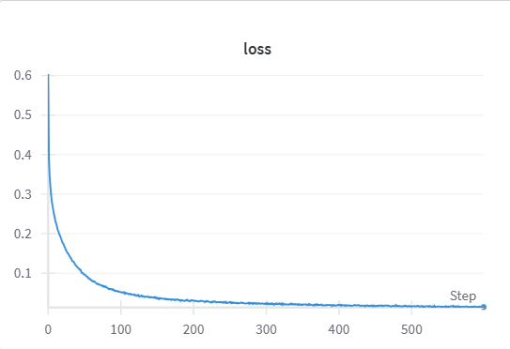
The above graph displays the loss output for each epoch or step as labeled here.
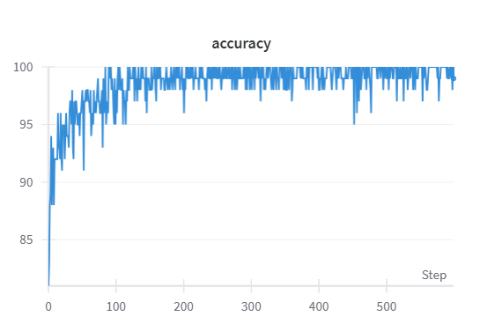
The above graph displays the accuracy output for each epoch or step as labeled here.
The testing algorithm was then run using the function described above from the testing file.
The testing algorithm output data can be found in “model_testing.csv”. The testing algorithm presented a model accuracy of 92.4.
Bonus Section
[1] Batch normalization and max pooling are both used in the framework as described in the Model Framework Implementation section.
[2] All code was written by the student in this project, and the base code provided from the instructor was not used.
[3] There is a residual stage used within the Convolutional Neural Network as described in the Model Framework Implementation section.

